Title: | Door control module  SW Architecture

History
Issue status  (Index) | Maturity/Date  (draft/invalid/valid)  (dd-mmm-yyyy) | Author  Department | Check/Release  Department | Description
1.1 | Draft  10-Nov-21 | Miguel Garcia | Miguel Garcia | Architecture to the Door control module project

Table of Contents
1 Purpose 3
2 Definitions and abbreviations 3
3 Realization constraints and targets 3
4 SW Functional Architecture 3
4.1 Table of functions 3
4.2 Table of functional Interfaces 4
4.3 Functional Interface 4
4.4 Functional Interaction 4
5 SW Physical Architecture 5
5.1 Physical Decomposition 5
5.2 Table of SW components 5
5.3 Table of Physical Interfaces 5
5.4 Physical Interfaces 6
5.5 Physical Interaction 6
5.6 Describe Dynamic Behavior 6
5.6.1 OS tasks 6
5.6.2 Interrupt Handling 6
5.6.3 Power Modes 7
5.7 Synchronization Mechanisms 7
6 Function to Physical Allocation 7
7 SW Requirements Allocation 8
8 SW Integration Plan 8
9 Functional Safety 8

Purpose
Crate the last release of the architecture to the project “Door control module” based on the requirements described and reviewed in the traceability matrix template and the requirements check list..

Definitions and abbreviations
Definitions
Special Byte | Special byte received to change the baud rate 55h

Abbreviations
Only SW Architecture specific abbreviations.
References
N° | Document name | Reference
1  2  3 | SW Requirements  Traceability_matrix_template  Requirements_chek_list

Realization constraints and targets
Correct operation of a system which controls, supervises, and administrates the door-locking, window position and the associated HW diagnostics of a 4-door vehicle.

A system that has no trouble in resolving operations for 4 doors independently

A system that has clear modularity to reuse parts in each of the 4 door configurations

A system that can respond efficiently to both remote and manual inputs

A system that can operate with a set of dynamic restrictions, for example limiting the window control based on a window lock functionality as well as the physical limitations of the window state.

A system that has always enough information about itself to interact with other car systems

SW Functional Architecture
Identify the functional behavior that will be implemented on Software.
Identify different SW functions with its corresponding interaction among them.
Identify and describe the signals and events used to share information among functions.

Table of functions
Function Name | Description
Get_AntiPinch_Value | Gets the anti-pinch value from the adc
Adc_Init | Initializes the adc configuration
Adc_Run | Implements the adc in a RTOS task
Dio_init | Initializes the dio configuration
Dio_Run | Implements the dio in a RTOS task
Dio_Read_doorlock | Reads the door lock status
Dio_Read_doorlockbutton | Reads the pin connected to the door lock button
Dio_Read_doorunlock | Reads the door unlock status
Dio_Read_doorunlockbutton | Reads the pin connected to the door unlock button
Dio_Read_Jumper0 | Reads the configuration jumper 0
Dio_Read_Jumper1 | Reads the configuration jumper 1
Dio_Read_PassangerWOpenB | Reads the passenger window open button
Dio_Read_PassangerWCloseB | Reads the passenger window close button
Dio_Read_RearRWOpenB | Reads the rear right window open button
Dio_Read_RearRWCloseB | Reads the rear right window close button
Dio_Read_RearLWOpenB | Reads the rear left window open button
Dio_Read_RearLWCloseB | Reads the rear left window close button
Dio_Read_RearWindowLockB | Reads the status of the window block button
Dio_Read_WindowClose | Reads the driver window close status
Dio_Read_WindowOpen | Reads the driver window open status
Dio_Read_WindowCloseB | Reads the driver window close button
Dio_Read_WindowOpenB | Reads the driver window open button
Dio_Writte_Doorlock_led | Writes on a red led indicating a lock actuation
Dio_Writte_DoorUnlock_led | Writes on a red green indicating a lock actuation
Signals_Init | Initializes the signals configuration
Signals_RunTx | Implements the transmission of signals in a RTOS task
Signals_RunRx | Implements the reception of signals in a RTOS task
Signals_Get_SysPwrMode | Gets the power mode of the car on the corresponding car frame
Signals_Get_ConfortCmd | Gets the comfort cmd of the car on the corresponding car frame
Signals_Set_WindowPos | Sets the current driver window position on the CAN frame
Signals_Set_LockingReq | Sets a door locking request from the driver or passenger door
Signals_Get_LockingReq_Driver | Gets a locking request if it was originated form the driver door
Signals_Get_LockingReq_Passenger | Gets a locking request if it was originated form the passenger door
Signals_Set_WindowOp | Sets a desired window operation. Used with a button press or a window operation request
Signals_Set_RearWindowLock | Sets the rear window lock state
Signals_Get_RearWindowLock | Gets the state of the rear window lock
Signals_Set_DoorLockSts | Sets a door locking state. Used only with driver and used with button states changes or can requests
Signals_Get_Passenger_DoorLockSts | Gets the current passenger door lock state
Button_Get_Door_Lock | Gets the current driver door lock button read after debounce
Button_Get_Door_Unlock | Gets the current driver door unlock button read after debounce
Button_Get_Window_Open | Gets the current driver window open button read after debounce
Button_Get_Window_Close | Gets the current driver passenger window close button read after debounce
Button_Get_PassengerWindow_Open | Gets the current passenger door lock button read after debounce
Button_Get_PassengerWindow_Close | Gets the current passenger door unlock button read after debounce
Button_Get_RearLeftWindow_Open | Gets the current rear left window open button read after debounce
Button_Get_RearLeftWindow_Close | Gets the current rear left window close button read after debounce
Button_Get_RearRightWindow_Open | Gets the current rear right window open button read after debounce
Button_Get_RearRightWindow_Close | Gets the current rear right window close button read after debounce
Button_Get_RearWindow_Lock | Gets rear window lock button read after debounce
Window_Init | Initializes the window configuration
Window_Init_Safety | Initializes the window safety configuration
Window_Run | Implements the window actuations in a RTOS task
Window_Run_Safety | Implements the window safety actuations in a RTOS task
Window_Set_Request | Sets a request to perform a window actuation
Window_Get_Status | Gets the current window status after an actuation
Window_Get_Operation | Gets the current window operation being executed
Door_Init | Initializes the door configuration
Door_Run | Implements the door actuations in a RTOS task
Door_Set_Request | Sets a request to perform a door actuation
Door_Get_Status | Gets the current door status after an actuation
WindowApp_Init | Initializes the window app configuration
WindowApp_Run | Implements the window app logic in a RTOS task
DoorApp_Init | Initializes the door app configuration
DoorApp_Run | Implements the door app logic in a RTOS task
HwConfigInit | Initializes the HwConfig reading the rumpers and sorting the configuration options
HwConfig_Get | Provides a way to read the current HwConfig

Table of functional Interfaces
Signal/Event | Description
iMessage | Format that describes a CAN message following a special framework sent through the network
iActionDoor | Information associated with the actuation and the procedure of the door action
iActionWindow | Information associated with the actuation and the procedure of the window action
iConfig | Digital signal indicating the read and the current configuration of the ECU
iMicroReads | Information associated with the read of all pins and peripherals connected
iActionLogic | Information associated with the execution of the logic using the previous information
iMicroWrite | Information associated with the write on all pins and the access of this data vy different SWC

Functional Interface
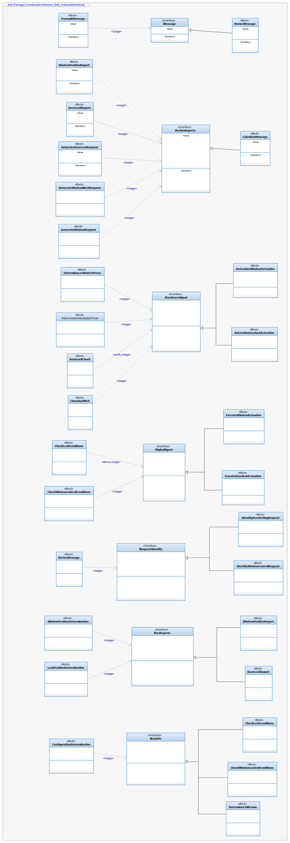

Functional Interaction
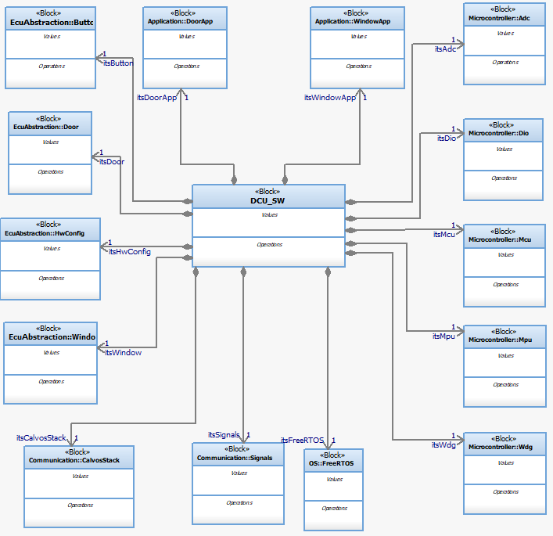

SW Physical Architecture
Define Physical architecture that will be implemented on Software with its corresponding SW decomposition.
Identify different SW Components with its corresponding interaction among them.
Identify and describe the signals and events used to share information among SW Components.

Physical Decomposition
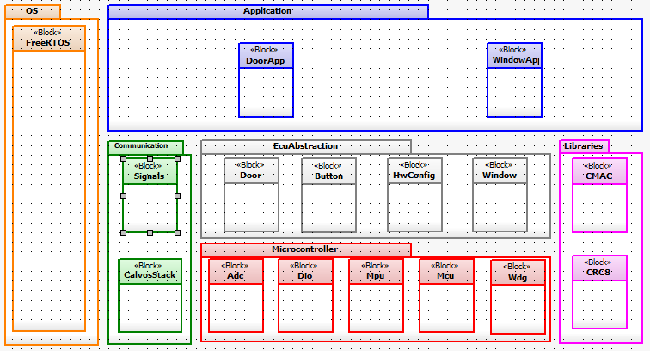

Table of SW components
SWC Name | Description | Estimated Size (KB)
Button | Handles all button operations (Lock and unlock, window up and window down), keeps track of the button state, and implements the debounce characteristic in both press and release | 1
Door | Handles the physical aspects of the door actuation at a ECU abstraction level, operates the complete looking action procedure and gives the corresponding APIs to the DoorApp | 1
HwConfig | Determines the correct current ECU version based on the configuration switches | 1
Window | Handles the physical aspects of the window actuation at a ECU abstraction level, operates the complete window up/down action procedure and gives the corresponding APIs to the WindowApp | 2
DoorApp | Gives the complete logic to the door locking operations, reading request, buttons and executing actions. Uses the Majority of APIs related to the door | 3
WindowApp | Gives the complete logic to the window operations, reading request, buttons, executing actions and checking conditions. Uses the Majority of APIs related to the window | 2
ADC | Configures the ADC necessary to the required functionalities | 3
DIO | Provides APIS to access the information received or written through hardware pins. | 4
MCU | Configures the necessary clock configurations | 5
FreeRTOS | Implements the RTOS functions and configuration | 2
Signals | Provides APIS to window, windowapp, door and doorapp to access information on the CAN bus | 3
Calvos | Provides the configuration to the CAN network according to the CAN network specifications | 2

Table of Physical Interfaces
Operation | Description
iDoorApp | Interfaced used to run the door logic on a RTOS task
iWindowApp | Interfaced used to run the window logic on a RTOS task
iHwConfig | Interface used the door app, window app and signals to choose the correct version of each function depending on the hw version
iSignals | Provides to the WindowApp and DoorApp a way to access the CAN network directly
iWindow | Provides the Windows App with complete functions to operate the window actions and read the current status
iButton | Gives access to the info gained by the button presses including the corresponding button debounce
iDoor | Provides the Door App with complete functions to operate the window actions and read the current status
iAdc | Gives access to the adc read
iDio | Provides the raw read and write functions al a PIN level
iMcu | Provides every SWC with the correct clock configuration and read.

Physical Interfaces
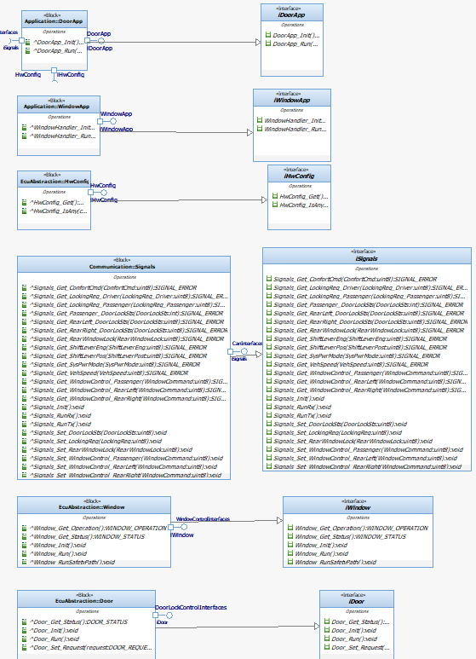

Physical Interaction
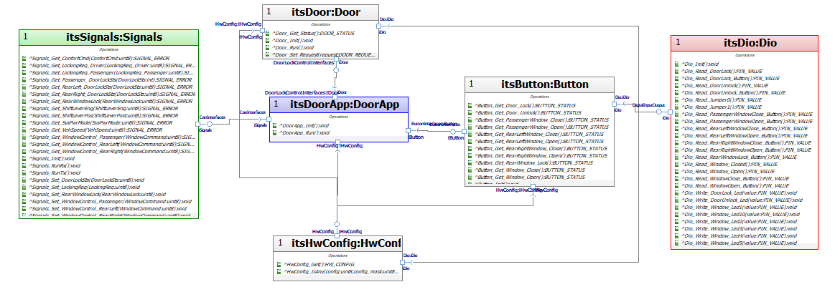
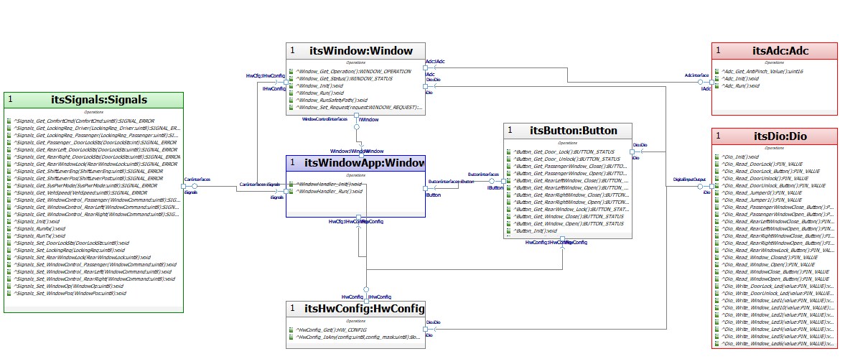

Describe Dynamic Behavior
This chapter shall be used to describe at physical level the runtime behavior of the SW.

OS tasks
OS task | Description | Periodicity | Period | Priority | CPU Load
app_task_10 | Task containing the functions that run the window and door actuations. | 10ms | 1 | 4 | 8%
app_task_20 | Task containing the functions that runs the signals APIs and get the information from the CAN network | 20ms | 1 | 3 | 6%
app_task_100 | Task containing the functions that run the windowapp and doorapp logic, the adc read and the window safety protocol | 100ms | 1 | 2 | 5%

Interrupt Handling
ISR task | Description | Priority | CPU Load
Button Press | Button interrupt to brake idle state and respond to the manual actuation request | 1 | 2%
Anti-pinch total interrupt | Request to immediately cancel all window actuations and start the anti-pinch procedure | 2 | 1%
Auto lock actuation priority | Request to immediately cancel the lock idle state and start the Auto lock procedure | 2 | 1%
RTOS | Interrupt to change task when needed in freeRTOS | 2 | 2%

Power Modes

Low Power Mode
The system does not operate in low power mode.

High Power Mode
All the system’s functions are declared in a high-power mode state.

Synchronization Mechanisms
To synchronize the system, we used an atom code approach.

Function to Physical Allocation
Perform the allocation of function to a SW component. One function shall be allocated to one SW component (if this cannot be achieved indicate a clarification wich part of the function shall be allocated to every SW component). One SW component might have
Function | SW component | Clarification
Get_AntiPinch_Value | Adc
Adc_Init | Adc
Adc_Run | FreeRTOS
Dio_init | Dio
Dio_Run | FreeRTOS
Dio_Read_doorlock | Dio
Dio_Read_doorlockbutton | Dio
Dio_Read_doorunlock | Dio
Dio_Read_doorunlockbutton | Dio
Dio_Read_Jumper0 | Dio
Dio_Read_Jumper1 | Dio
Dio_Read_PassangerWOpenB | Dio
Dio_Read_PassangerWCloseB | Dio
Dio_Read_RearRWOpenB | Dio
Dio_Read_RearRWCloseB | Dio
Dio_Read_RearLWOpenB | Dio
Dio_Read_RearLWCloseB | Dio
Dio_Read_RearWindowLockB | Dio
Dio_Read_WindowClose | Dio
Dio_Read_WindowOpen | Dio
Dio_Read_WindowCloseB | Dio
Dio_Read_WindowOpenB | Dio
Dio_Writte_Doorlock_led | Dio
Dio_Writte_DoorUnlock_led | Dio
Signals_Init | Calvos
Signals_RunTx | FreeRTOS
Signals_RunRx | FreeRTOS
Signals_Get_SysPwrMode | Signals
Signals_Get_ConfortCmd | Signals
Signals_Set_WindowPos | Signals
Signals_Set_LockingReq | Signals
Signals_Get_LockingReq_Driver | Signals
Signals_Get_LockingReq_Passenger | Signals
Signals_Set_WindowOp | Signals
Signals_Set_RearWindowLock | Signals
Signals_Get_RearWindowLock | Signals
Signals_Set_DoorLockSts | Signals
Signals_Get_Passenger_DoorLockSts | Signals
Button_Get_Door_Lock | Button
Button_Get_Door_Unlock | Button
Button_Get_Window_Open | Button
Button_Get_Window_Close | Button
Button_Get_PassengerWindow_Open | Button
Button_Get_PassengerWindow_Close | Button
Button_Get_RearLeftWindow_Open | Button
Button_Get_RearLeftWindow_Close | Button
Button_Get_RearRightWindow_Open | Button
Button_Get_RearRightWindow_Close | Button
Button_Get_RearWindow_Lock | Button
Window_Init | Window
Window_Init_Safety | Window
Window_Run | FreeRTOS
Window_Run_Safety | FreeRTOS
Window_Set_Request | Window
Window_Get_Status | Window
Window_Get_Operation | Window
Door_Init | Door
Door_Run | FreeRTOS
Door_Set_Request | Door
Door_Get_Status | Door
WindowApp_Init | WindowApp
WindowApp_Run | FreeRTOS
DoorApp_Init | DoorApp
DoorApp_Run | FreeRTOS
HwConfigInit | HwConfig
HwConfig_Get | HwConfig

SW Requirements Allocation
Elements located in the traceability matrix template

SW Integration Plan
Identify the dependencies for SW construction. Identify hierarchy for implementation. Indicate the integration steps for SW construction.

Integration Step | Description | SW components | Comments
1.-OS and microcontroler | Integrate all the functions related to freeRTOS and the configuration of the microcontroler | FreeRTOS  ADC  DIO  MCU
2.-ECU abstraction | Work on the basic configuration to design the basic operation of the actuators | Door  Window  Button  HwConfig
3.-Signals | Implement the can newtowk and integrate a way for a node to access the information | Calvos  CanPal  Signals
4.-Application | Integrate all function above to design the logic of the Window and door actions with all the detail | WindowApp  DoorApp

Functional Safety
This chapter will be fill during Module 5

